Jadavpur University

Department of Electronics and Telecommunication Engineering,

Faculty of Engineering & Technology

DSA LAB REPORT

2nd Year Second Semester 2020



Name : RAHUL SAHA

Roll: 001910701009

Group 1

**IMPLEMENTATION OF VARIOUS GRAPH TRAVERSAL SCHEMES**

Date Of Submission: 19/05/2021

**BREADTH FIRST TRAVERSAL**

**Q. Given a graph G= (V, E) and a source vertex s, implement Breadth-First-Search (BFS) and grow a BFS tree with root as s. Show some intermediate outputs as well.**

**Introduction:**

Breadth First Traversal (or Search) for a graph is similar to Breadth First Traversal of a tree . The only catch here is, unlike trees, graphs may contain cycles, so we may come to the same node again. To avoid processing a node more than once, we use a boolean visited array. For simplicity, it is assumed that all vertices are reachable from the starting vertex.

**Principle**

The algorithm discovers all vertices at distance k from source vertex s before discovering any vertices at distance k+1.

**Algorithm for BFS:**

|  |
| --- |
| 1. SET STATUS = 1 (ready state) for each node in G 2. Enqueue the starting node A and set its STATUS = 2 (waiting state) 3. Repeat Steps 4 and 5 until QUEUE is empty 4. Dequeue a node N. Process it and set its STATUS = 3 (processed state). 5. Enqueue all the neighbours of N that are in the ready state (whose STATUS = 1) and set their STATUS = 2 (waiting state) [END OF LOOP] 6. EXIT |
|  |

**Source Code:**

|  |
| --- |
| **#include <stdio.h>** **#include <stdlib.h>** **#define SIZE 40** **#define MAX 100** **int** **array**[MAX];  **typedef** **struct n_ary_tree{**  **int** data;  **struct n_ary_tree *firstChild;**  **struct n_ary_tree *nextSibling;** }tree;  **typedef** **struct queue_list {**  **int** items[SIZE];  **int** front;  **int** rear; }**queue**;  **typedef** **struct adjacency_list_node {**  **int** dest;  **struct adjacency_list_node* next;** }node;  **typedef** **struct Graph_Structure {**  **int** Vertices;  node** adj_list;  **int**\* visited; }Graph;  node* create_node(**int** dest) {  node* newNode = (node*) **malloc**(**sizeof**(node));  newNode->dest = dest;  newNode->next = **NULL**;  **return** newNode; }    Graph* create_graph(**int** vertices) {  Graph* graph = (Graph*)**malloc**(**sizeof**(Graph));  graph->Vertices = vertices;   graph->adj_list = (node**)**malloc**(vertices * **sizeof**(node*));  graph->visited = (**int**\*)**malloc**(vertices * **sizeof**(**int**));   **int** i;  **for** (i = 0; i < vertices; i++) {  graph->adj_list[i]= **NULL**;  graph->visited[i] = 0;  }  **return** graph; }  **void** add_edge(Graph* graph, **int** src, **int** dest) {  node* newNode = create_node(dest);  newNode->next = graph->adj_list[src];  graph-> adj_list[src]= newNode;   newNode = create_node(src);  newNode->next = graph->adj_list[dest];  graph->adj_list[dest]= newNode; }  //Function to create a queue **queue**\* create_queue() {  **queue**\* q = (**queue**\*)**malloc**(**sizeof**(**queue**));  q->front = -1;  q->rear = -1;  **return** q; }  // Check if the queue is empty **int** isEmpty(**queue**\* q) {  **if** (q->rear == -1)  **return** 1;  **else**  **return** 0; }  // Adding elements into queue **void** enqueue(**queue**\* q, **int** value) {  **if** (q->rear == SIZE - 1)  **printf**("\nQueue is Overflow");  **else** {  **if** (q->front == -1)  q->front = 0;  q->rear++;  q->items[q->rear] = value;  } }  // Removing elements from queue **int** dequeue(**queue**\* q) {  **int** item;  **if** (isEmpty(q)) {  **printf**("\nQueue is empty\n");  item = -1;  } **else** {  item = q->items[q->front];  **printf**("\nThe Value Dequeued is:%d",item);  q->front++;  **if** (q->front > q->rear) {  **printf**("\nResetting queue");  q->front = q->rear = -1;  }  }  **return** item; }  // Print the queue **void** print_queue(**queue**\* q) {  **int** i = q->front;   **if** (isEmpty(q)) {  **printf**("\nQueue is empty\n");  } **else** {  **printf**("\nQueue contains: ");  **for** (i = q->front; i < q->rear + 1; i++) {  **printf**("%d ", q->items[i]);  }  } }  **void** bfs(Graph* graph, **int** start_vertex) {  **queue**\* q = create_queue();  graph->visited[start_vertex] = 1;  enqueue(q, start_vertex);  **int** i=0;  **while** (!isEmpty(q)) {  print_queue(q);  **int** current_vertex = dequeue(q);  **printf**("\nVisited %d\n\n", current_vertex);  **array**[i]=current_vertex;  i++;  node* temp = graph->adj_list[current_vertex];   **while** (temp) {  **int** adj_vertex = temp->dest;  **if**(graph->visited[adj_vertex]==1){  **printf**("\nVertex %d which is adjacent to %d is already visited",adj_vertex,current_vertex);  }  **else** **if**(graph->visited[adj_vertex] == 0) {  graph->visited[adj_vertex] = 1;  **printf**("\nThe Value %d is a child to the node %d",adj_vertex,current_vertex);  enqueue(q, adj_vertex);  }  temp = temp->next;  }  } }  //Fuction to print the graph **void** print_graph(Graph* graph) {  **int** v;  **for** (v = 0; v < graph->Vertices; v++) {  node* temp = graph->adj_list[v];  **printf**("\n Adjacency list of vertex %d\n ", v);  **while** (temp) {  **printf**("%d -> ", temp->dest);  temp = temp->next;  }  **printf**("\n");  } }  //driver code **int** main() {  system("cls");  **printf**("\t\tBreadth First Search in Graph");  **int** vertices,ver1,ver2;  **char** ch;  **printf**("\n\nEnter the number of Vertices: ");  **scanf**("%d",&vertices);  Graph* graph = create_graph(vertices);  **do**{  **printf**("\nEnter the vertices you want to enter an edge in between: ");  **scanf**("%d %d",&ver1,&ver2);  add_edge(graph,ver1,ver2);  **printf**("Do you want to insert more edges->Y to continue and N to Exit:");  fflush(**stdin**);  **scanf**("%c",&ch);  }**while**(ch=='Y'||ch=='y');  **printf**("\nDisplaying the Graph in adjacency List Format\n");  print_graph(graph);  **printf**("\n\n");  bfs(graph, 0);  **printf**("\n\nThe Breadth first search for the Given Graph is:\n");  **for**(**int** i=0;i<vertices;i++){  **printf**("%d ",**array**[i]);  }  **printf**("\n\n");  **return** 0; } |

*Let us take this example:*

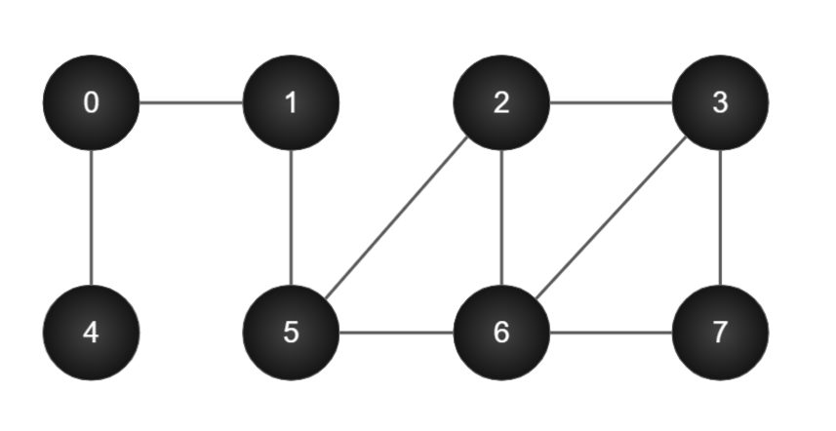

Let,

White nodes represent all the nodes that are not visited yet.

Purple nodes represent the nodes whose adjacency list is being checked and scanned

Red nodes represent the nodes which have been traversed.

Initially all the nodes are white

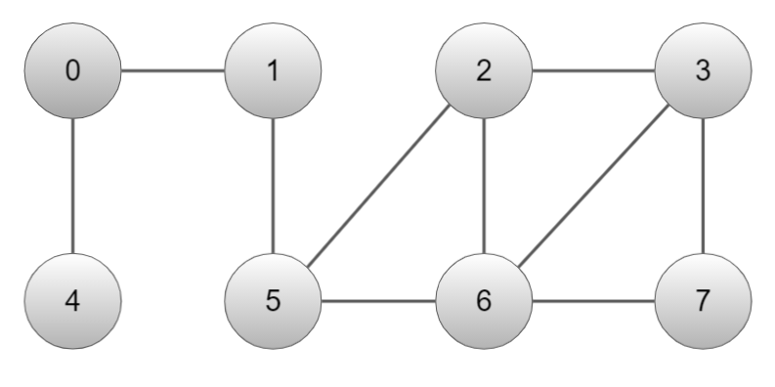

First, vertex 0 is scanned and its adjacency list is checked

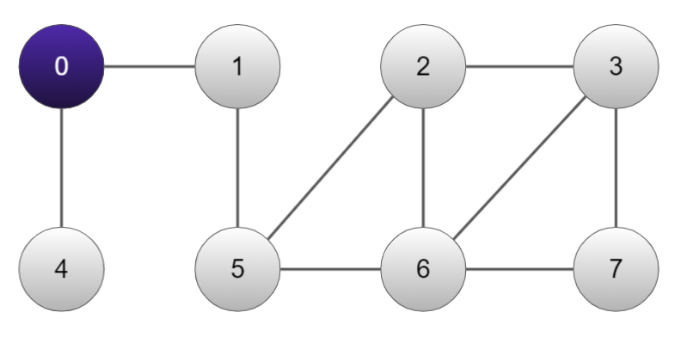

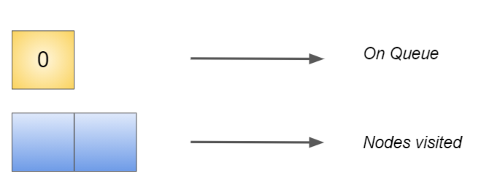

Adj[0] → 4,1

Now, 4 being the adjacent node of 0 is scanned and node 0 is completely explored.

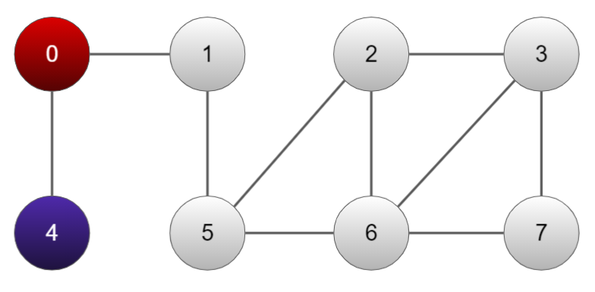

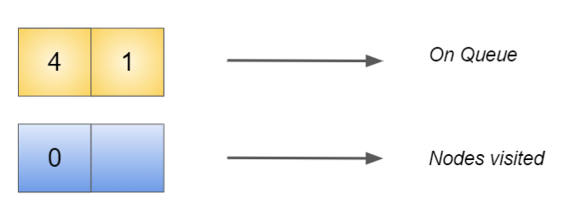

Adj[4] → Φ

Next, 1 being the adjacent node of 0 is scanned and node 4 is visited completely.

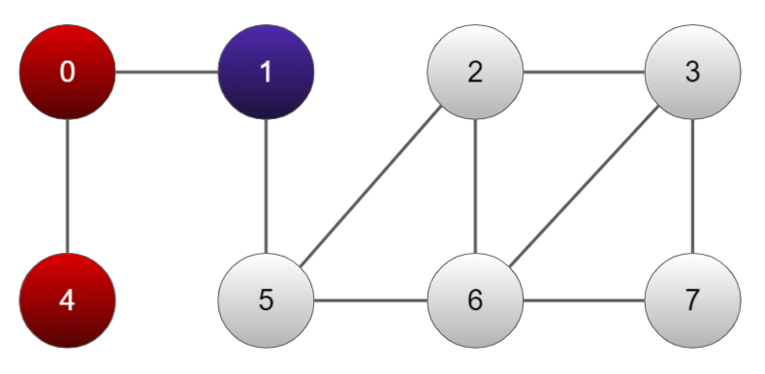

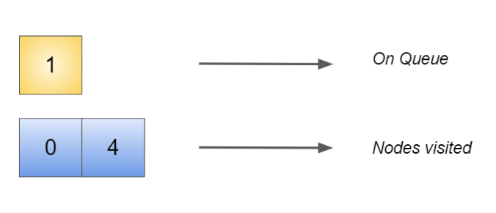

Adj[1] → 5

Next, 5 being the adjacent node of 1 is scanned and node 1 is visited completely.

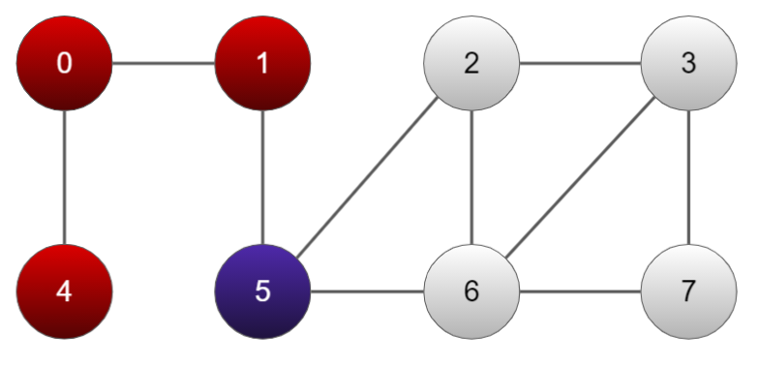

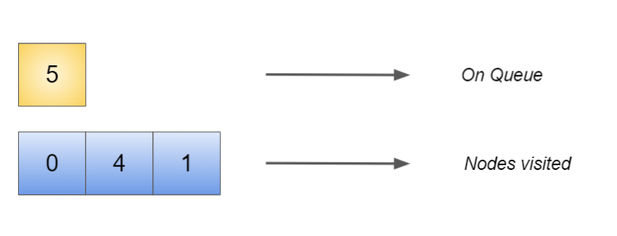

Adj[5] → 6,2

Next, 6 being the adjacent node of 5 is scanned and node 5 is visited completely.

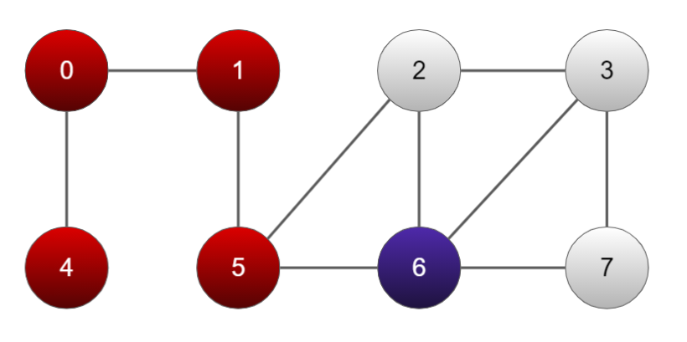

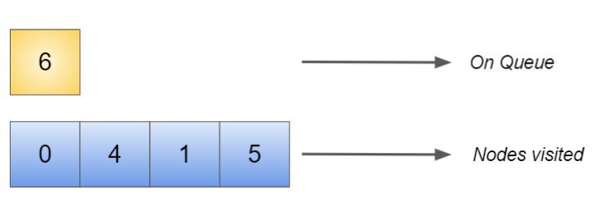

Adj[6] → 2,3,7

Next, 2,3,7 being the adjacent nodes of 6 is scanned one by one

First, 2 is scanned

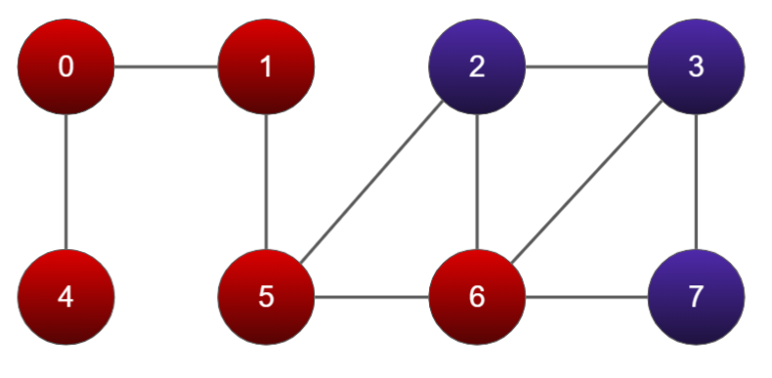

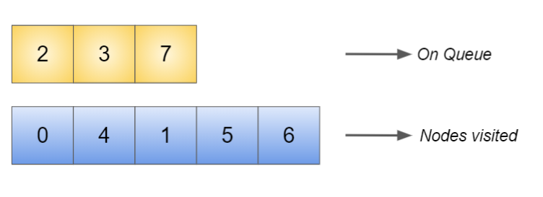

Adj[2] → 3

Now, 3 is scanned

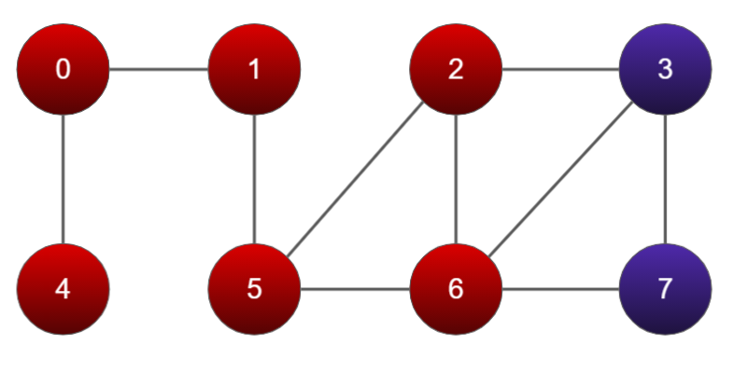

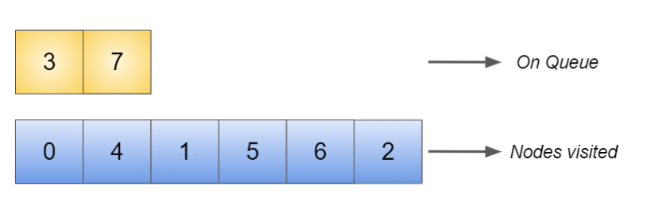

Now 7 is scanned

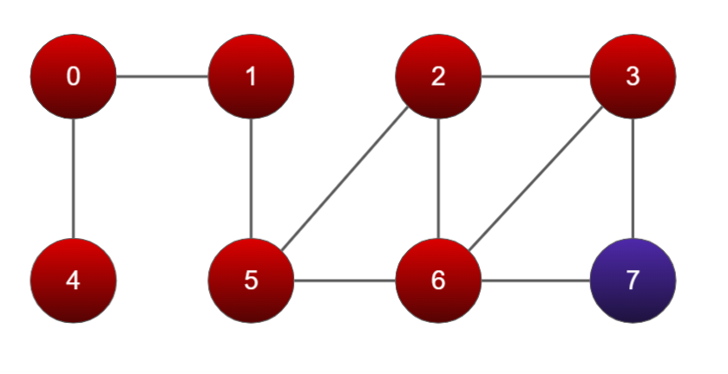

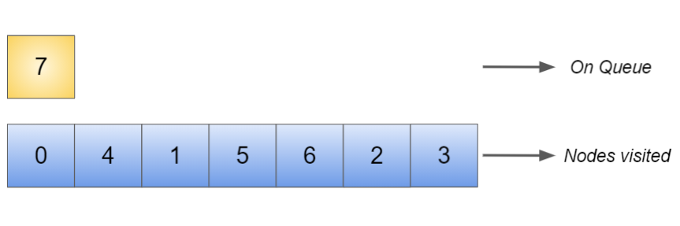

At last, 7 is traversed

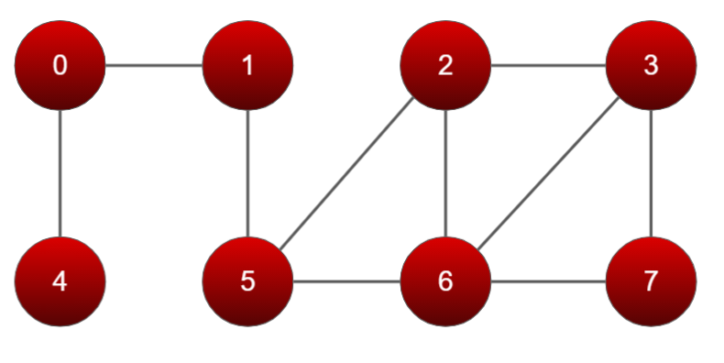

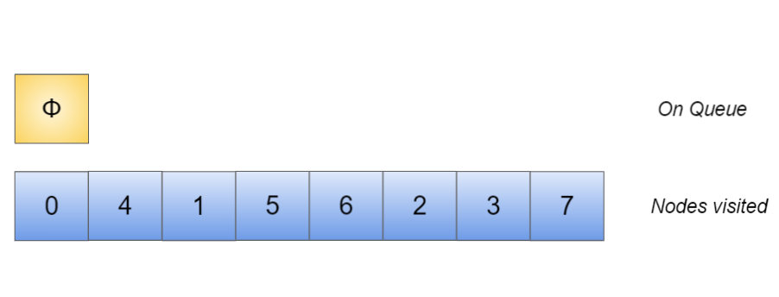

Here is the adjacency list of all the nodes

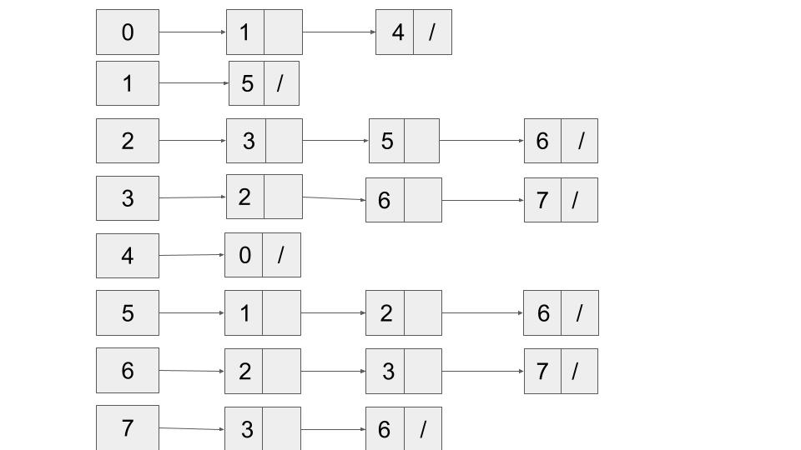

**OUTPUT CONSOLE**

**Vertices and edges are being inserted**

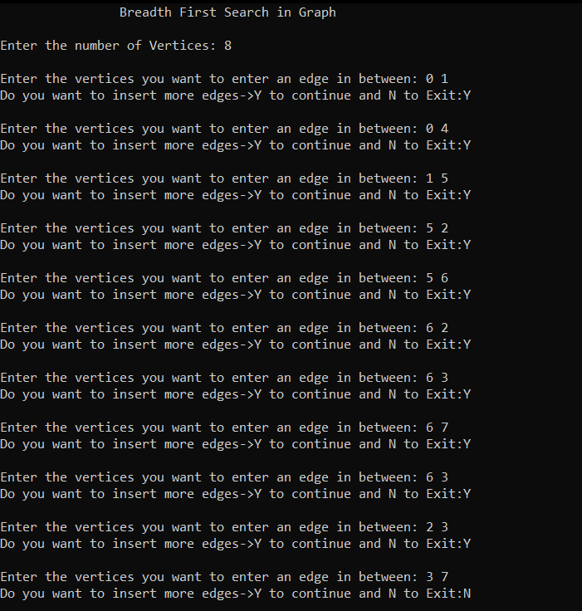

**The adjacency list**

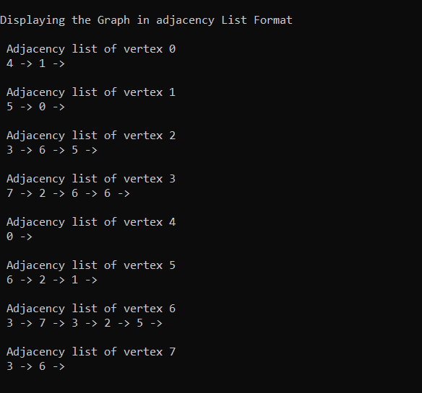

**Graph traversal (BFS)**

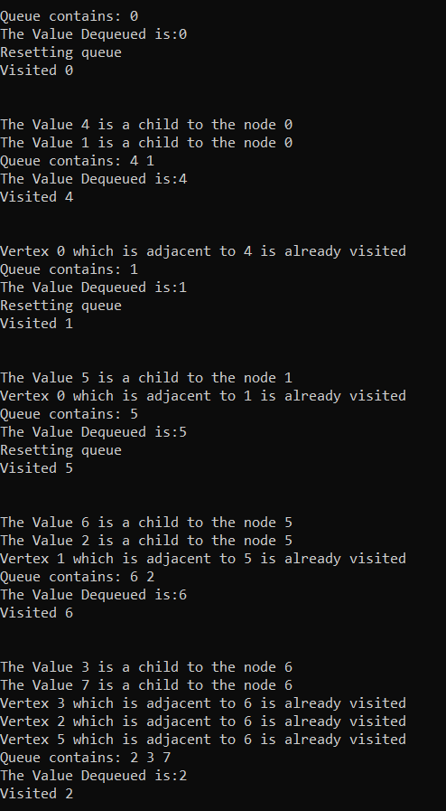

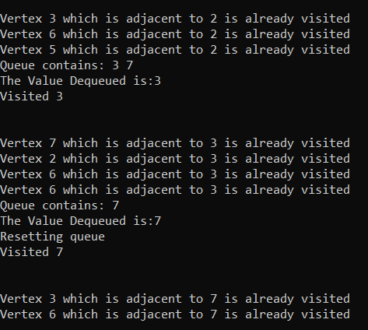

**The Breadth First Traversal**

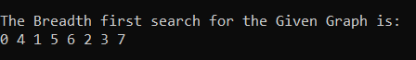

**Depth First Traversal**

**Q. Given a directed graph G=(V, E), implement Depth-First-Search (DFS). Your program should invoke DFS_VISIT(u) for any vertex u. Show some outputs as well.**

**Introduction**

Depth First Traversal (or Search) for a graph is similar to Depth First Traversal of a tree. The only catch here is, unlike trees, graphs may contain cycles, a node may be visited twice. To avoid processing a node more than once, use a boolean visited array.

**Principle**

Edges are explored out of the most recently discovered vertex v, that still has unexplored edges having it. When all of v’s edges have been explored, the search backtracks to explore edges having the vertex from which v was discovered. The process continues until we have discovered all the vertices that are reachable from the original source vertex.

**Algorithm for DFS:**

|  |
| --- |
| Step 1: SET STATUS = 1 (ready state) for each node in G Step 2: Push the starting node A on the stack and set its STATUS = 2 (waiting state) Step 3: Repeat Steps 4 and 5 until STACK is empty Step 4: Pop the top node N. Process it and set its STATUS = 3 (processed state) Step 5: Push on the stack all the neighbours of N that are in the ready state (whose STATUS = 1) and set their STATUS = 2 (waiting state) [END OF LOOP] Step 6: EXIT |

**Source Code:**

|  |
| --- |
| // DFS algorithm in C  **#include <stdio.h>** **#include <stdlib.h>** **#define MAX 100** **int** **stack**[MAX]; **int** top=-1;  **typedef** **struct adjacency_list_node {**  **int** dest;  **struct adjacency_list_node* next;** }node;  **typedef** **struct Graph_Structure {**  **int** Vertices;  node** adj_list;  **int**\* visited; }Graph;  **void** push(**int** item) {     **stack**[++top] = item;  }   **int** pop() {   **printf**("\nThe value poped is: %d",**stack**[top]);  **return** **stack**[top--];  }   **void** print_stack(){  **printf**("\nThe Stack contains: ");  **for**(**int** k=top;k>=0;k--){  **printf**("%d ",**stack**[k]);  } }  **int** isEmpty() {  **if** (top == -1)  **return** 1;  **else**  **return** 0; }  // Create a node node* create_node(**int** dest) {  node* newNode = (node*) **malloc**(**sizeof**(node));  newNode->dest = dest;  newNode->next = **NULL**;  **return** newNode; }  // Create graph Graph* create_graph(**int** vertices) {  Graph* graph =(Graph*)**malloc**(**sizeof**(Graph));  graph->Vertices = vertices;   graph->adj_list =(node**)**malloc**(vertices * **sizeof**(node*));   graph->visited =(**int**\*)**malloc**(vertices * **sizeof**(**int**));   **int** i;  **for** (i = 0; i < vertices; i++) {  graph->adj_list[i] = **NULL**;  graph->visited[i] = 0;  }  **return** graph; }  // Add edge **void** add_edge(Graph* graph, **int** src, **int** dest) {  // Add edge from src to dest  node* newNode = create_node(dest);  newNode->next = graph->adj_list[src];  graph->adj_list[src] = newNode;   // Add edge from dest to src  newNode = create_node(src);  newNode->next = graph->adj_list[dest];  graph->adj_list[dest] = newNode; }  // DFS algo **void** DFS_visit(Graph* graph, **int** start_vertex) {  graph->visited[start_vertex] = 1;  push(start_vertex);  **int** i=0;  **while** (!isEmpty()) {  print_stack();  **int** current_vertex = pop();  **printf**("\nVisited %d\n\n", current_vertex);  node* temp = graph->adj_list[current_vertex];  **while** (temp) {  **int** adj_vertex = temp->dest;  **if**(graph->visited[adj_vertex]==1){  **printf**("\nVertex %d which is adjacent to %d is already visited",adj_vertex,current_vertex);  }  **else** **if**(graph->visited[adj_vertex] == 0) {  graph->visited[adj_vertex] = 1;  **printf**("\nThe unvisited vertex %d is adjacent to %d",adj_vertex,current_vertex);  push(adj_vertex);  }  temp = temp->next;  }  } }  //Function to print the graph **void** print_graph(Graph* graph) {  **int** v;  **for** (v = 0; v < graph->Vertices; v++) {  node* temp = graph->adj_list[v];  **printf**("\n Adjacency list of vertex %d\n ", v);  **while** (temp) {  **printf**("%d -> ", temp->dest);  temp = temp->next;  }  **printf**("\n");  } }  //driver function **int** main() {  system("cls");  **printf**("\t\tDepth First Search in Graph");  **int** vertices,ver1,ver2,vertex;  **char** ch;  **printf**("\n\nEnter the number of Vertices: ");  **scanf**("%d",&vertices);  Graph* graph = create_graph(vertices);  **do**{  **printf**("\nEnter the vertices you want to enter an edge in between: ");  **scanf**("%d %d",&ver1,&ver2);  add_edge(graph,ver1,ver2);  **printf**("Do you want to insert more edges->Y to continue and N to Exit:");  fflush(**stdin**);  **scanf**("%c",&ch);  }**while**(ch=='Y'||ch=='y');  **printf**("\nDisplaying the Graph in adjacency List Format\n");  print_graph(graph);  **printf**("\n\n");  **printf**("Enter the vertex you want to search the dfs of: ");  **scanf**("%d",&vertex);  **printf**("\n");  DFS_visit(graph, vertex);  **printf**("\n\n");  **return** 0; } |

*Taking the same example as in the previous case*



Let,

White nodes represent all the nodes that are not visited yet.

Purple nodes represent the nodes whose adjacency list is being checked and scanned

Red nodes represent the nodes which have been traversed.

Suppose we want to start from node 0

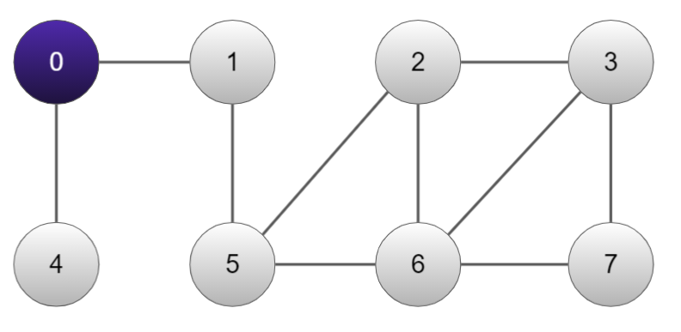

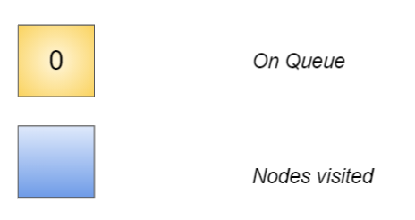

Adj[0] → 1,4

Traversing adjacent node of 0, i.e. 1

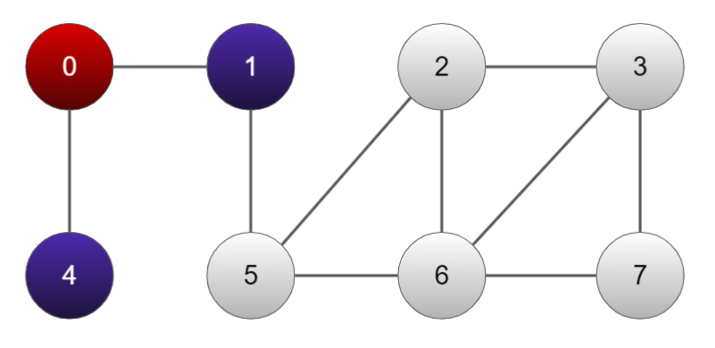

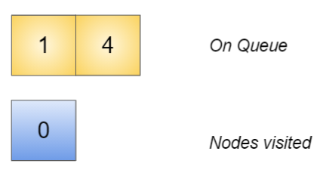

Adj[1] → 5

Traversing through 5

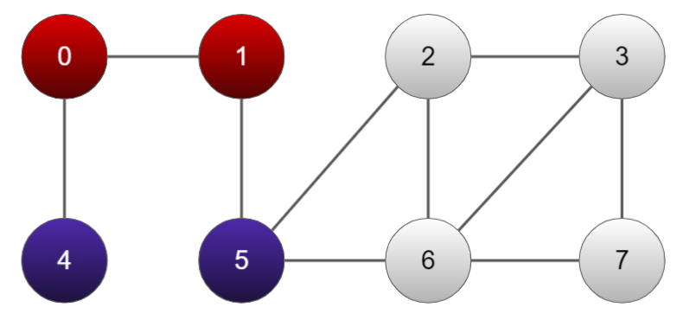

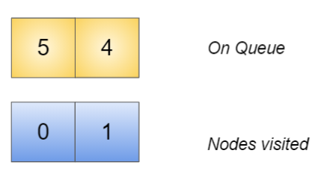

Adj[5] → 2,6

Traversing through 2 now

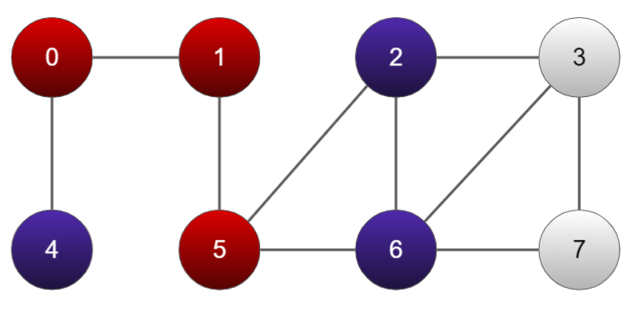

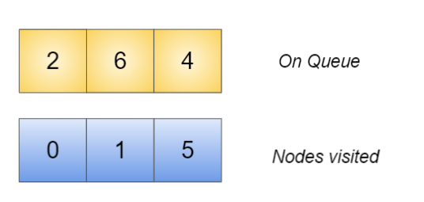

Adj[2] → 3,6,5

Out of which, the nodes 5 and 6 are already visited

Traversing node 3

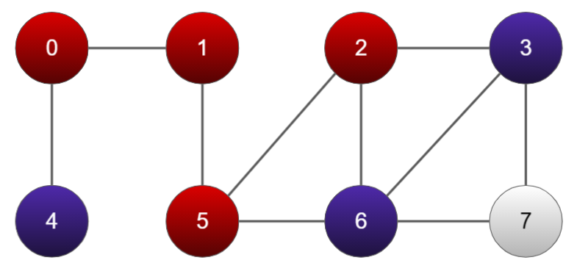

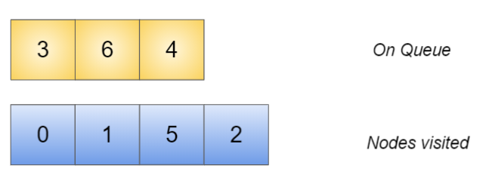

Adj[3] → 2,6,7

Out of which, nodes 2 and 6 are already visited

Traversing through node 7

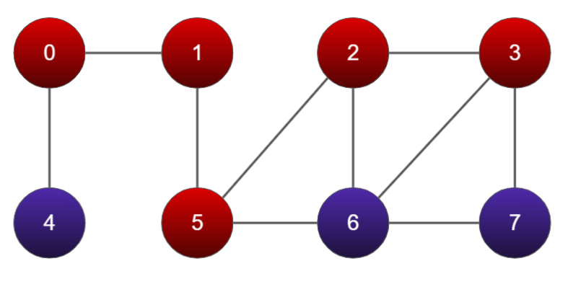

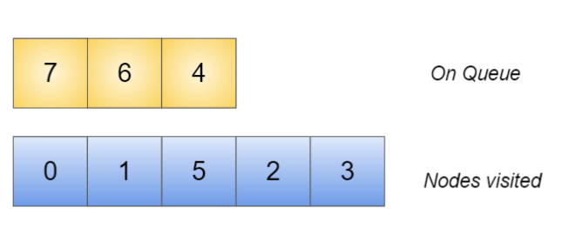

Adj[7] → 3,6

Out of which, node 3 is already visited

Traversing through 6 which is immediate on the queue

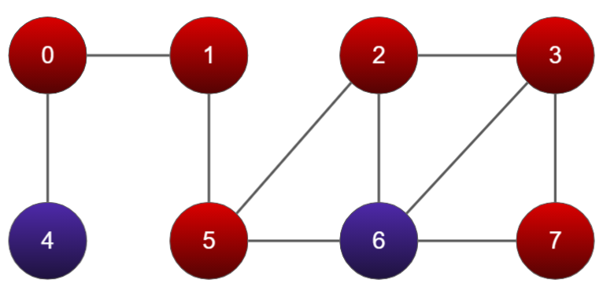

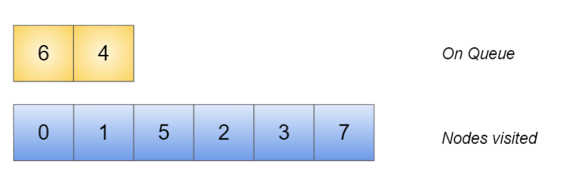

Traversing through 4 which is immediate on the queue

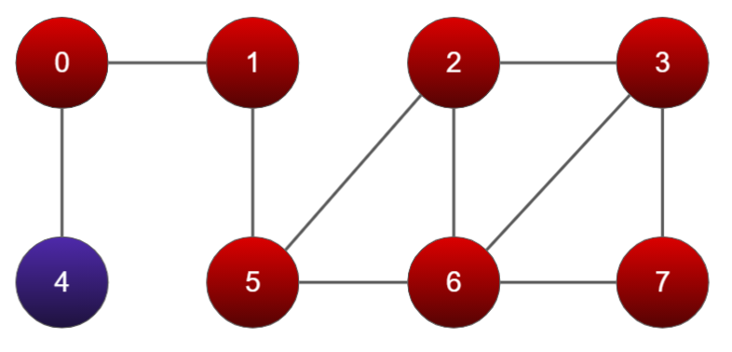

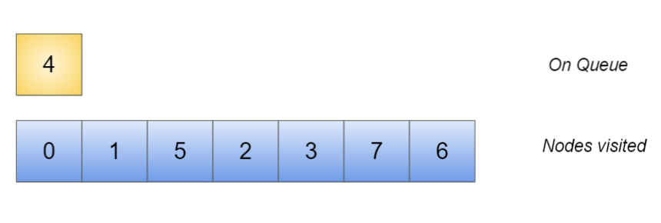

Finally all nodes are traversed

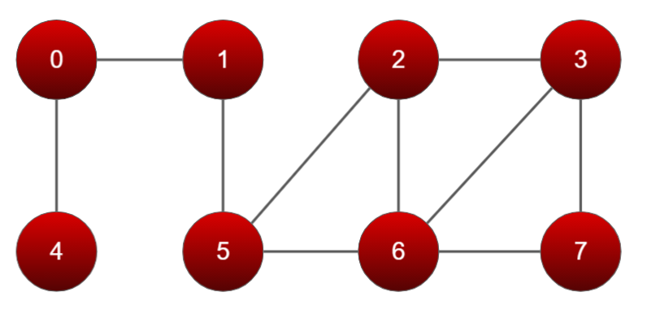

**ADJACENCY LIST:**



**OUTPUT CONSOLE**

Edges and vertices are inserted according to the example schematic

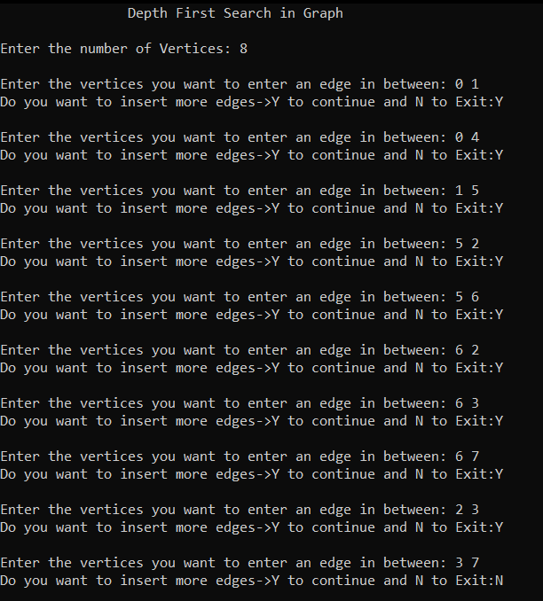

**Adjacency list:**

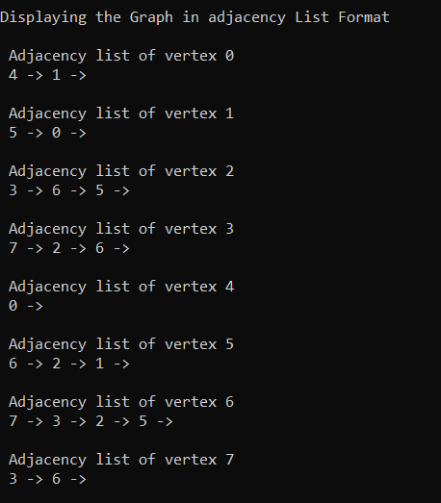

**Suppose we want to start from 0**

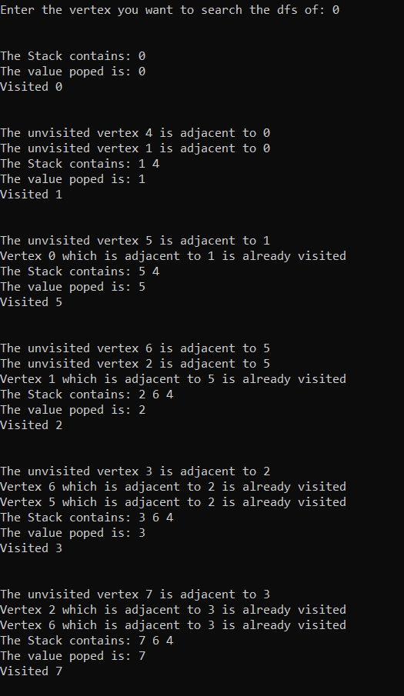

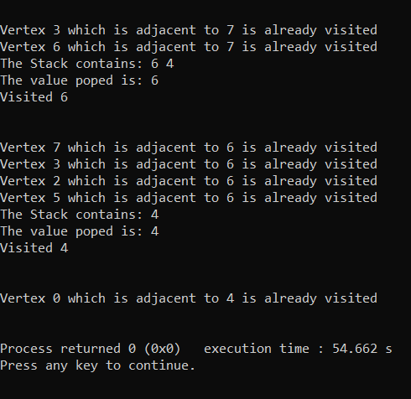

**CONCLUSION**

A Graph is a non-linear data structure consisting of nodes and edges. The nodes are sometimes also referred to as vertices and the edges are lines or arcs that connect any two nodes in the graph.

Mainly, the traversal of a graph can be done in two ways primarily:

1. Breadth first search which mainly prioritises all the nodes in the same breadth followed by the nodes in the other breadth/level.
2. Depth first search mainly prioritises recurrence of adjacent nodes to the highest depth and followed by backtracking and traversing the rest of the nodes.

Here in this lab, I explained the traversal process in both the traversal schemes step by step and showing the status of the queue after each step.